Stock valuation

I want to build charts for companies like this:
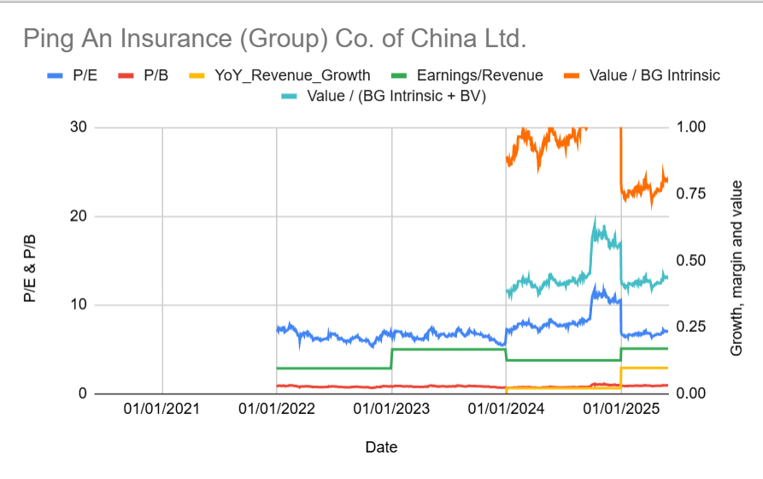

I want a weekly data point on price for each company.

Then I want the most recent financial data available to calculate the following each week that it data is available to calculate:
- P/E (Price / earnings)
- P/B (Price / Book)
- YoY Revenue Growth (most recent 12 month revenue / revenue from 12 months prior)
- Earnings / revenue
- Value / BG intrinsic (Ben Graham intrinsic value)
- Value / (BG intrinsic + BV) (Ben Graham intrinsic value + Book Value)

